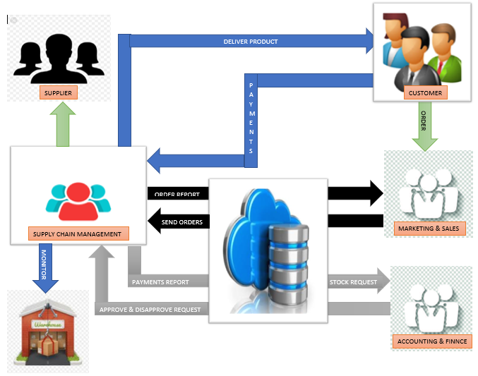**SYSTEM ARCHITECTURE**